**Lecture: Notifications and Handlers**

The most common method of conditional execution in a playbook, learn how to set and fire an event to run a separate task.

If this thing run then run the other thing otherwise not

Vim notify.yaml

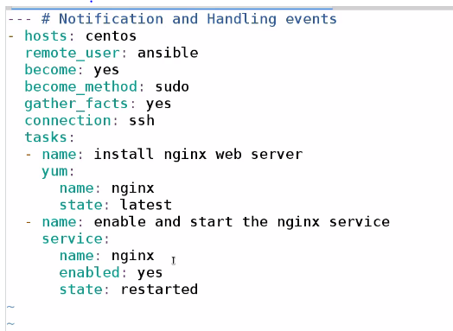

Run 1st time

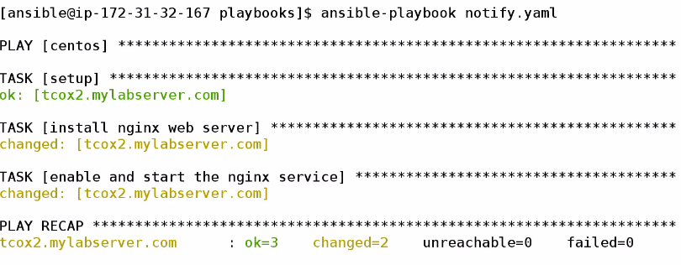

Run 2nd time

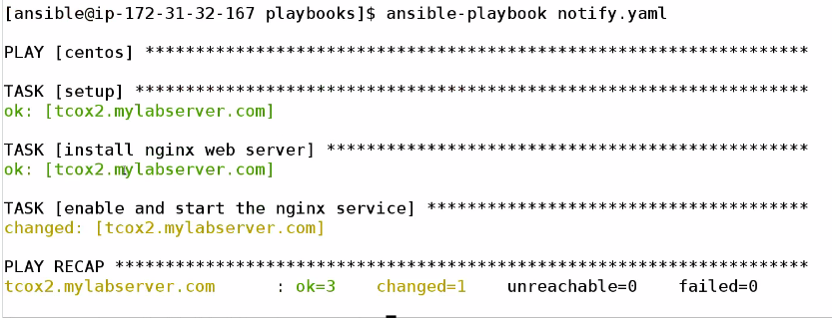

So we could see every time I run the playbook regardless of the fact ,it is restarted my nginx server

In some case we may have problem ….so we want to implement conditional scenario like if nginx installed then only second module fire up ..in this case start and enable the service .

Now we gonna use notify and handler to achive that

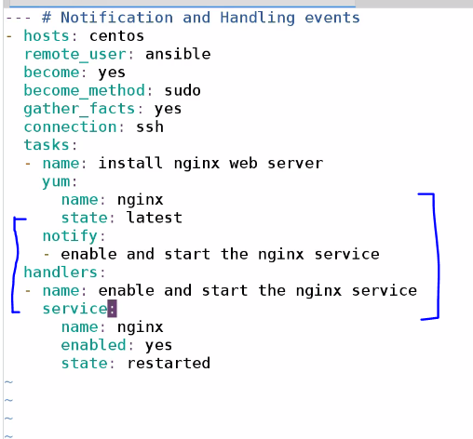

So now we goona clear the nginx and then run the playbook ,,,,,and see the changes

Run 1st time

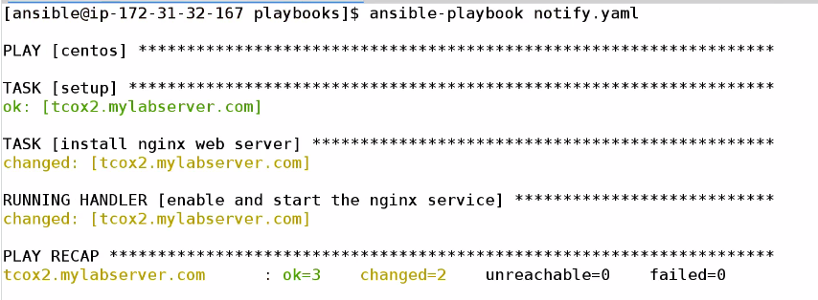

Run 2nd time

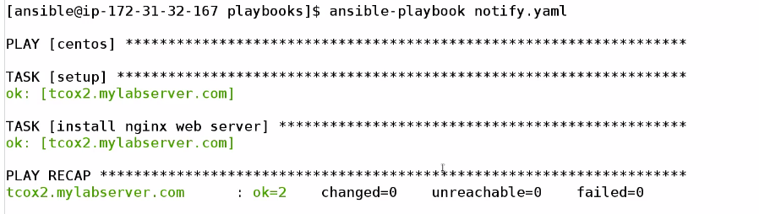

WE COULD OBSERVE THAT AS TASK 1 NOT CHENGED DO HANDLER IS NOT CALLED

HANDLER WILL ONLY CALLED WHEN NOTIFY FIRES

AND NOTIFY ONLY FIRES WHEN TASK IS COMPLETED SUCCESFULLY